Education 20/20 Inc.

Education 20/20 Inc. is an independent, broad based, national, not-for-profit education organization, located in Charlottetown, PEI and is governed by a volunteer Board of Directors.

Vision: A quality education for every Canadian.

Mission: To support and strengthen a culture of learning for all Canadians.

Mandate: To contribute to the education of our citizens by providing information, encouragement and support for a quality education for all citizens.

Activities:
- Education Award,
- Monthly electronic newsletter. Website, Occasional papers,
- Research, consultation. workshops
Directors:
- Don Glendenning, President
- Bill Whelan, Vice President
- Tom White-Hassler
- Katherine McQuaid
- Donald DesRoches
- Amber Jadis
- Tess Miller
- Ronnie McIntosh
- Ross Reid

Pub/Bro/Frame/11


AN
EDUCATION
FRAMEWORK

Education 20/20 Inc.
101 Kent St., PO Box 624/rue Kent, BP 624
Charlottetown, PEI C1A 1M0 Canada
Tel: 902-892-2060
CONTENTS
- Learner
- Road of life
- Education
- Principles
- Learning
- Teaching
- Functions
- A Call to Action
- Quality
- Rating scale
- Learning path
- Levels

THIS BOOKLET
There is a shortage of current and independent information about education in the public domain; there is also a lack of debate especially between those who provide educational services and those who use them. This booklet attempts to:
- Respond to questions and conversations with Islanders with an interest and concern about the community in which we live and work
- Provide a framework for asking questions and making decisions about educational matters in your school district.
- Provide a ready reference to current information and thinking on the subject
- Provoke debate about education within the community at large and with educators

OUR THANKS TO:
• Louise Carota for her rendition of the road of life
• Cozy for layout and editing
• Sponsors

FURTHER INFORMATION
- Adams, Robert E, Lance Hong and Luke Steinke, DACUM: The Seminal Book,
- Hall, Dr. Tom and Don Glendenning, The Canadian Restructured School Plan, (CRSP)
- Aitken, William, The Story of the Eight Year Study,
- Fadulu, Lolade, “Why is the US so Bad at Worker Retraining”, Atlantic, January 4, 2018

INNOVATION IN ACTION
- Differentiated Staffing- Bishop Carrol High School, Calgary
- Blended learning - Sail Academy, BC
- Full Service schools, Toronto
- individually designrd schedules - Jason Lee Middle School, Tacoma, Washington –
- Democratic management Hanover, New Hampshire –

PROFICIENCY LEVELS

Testing and grading is associated with schools:
- Formative assessment is an interactive process between student and teacher designed to inform both parties how well students are learning what teachers are teaching. It is considered feedback to students, shared fully and probably confidentially snd unique to each learner. Forative assessment eill likely be course or incident based and sometimes anonymous,s and not even connected to passing or grading.
- Summative assessment is used to when establishing a person’s level or grade in a subject or fieldie Grade 10 math. Summative assessment has a regulatory function responding to society’s demand for minimum levels of performance in certain life roles; although important,summative assessment is not a teaching function and, therefore, should be carried out by an independent body. Given that programs are outcome based, evaluation should be criterion referenced may take into account more than course content and academic success depending on its purpose including discussion, cooperation, attendance, presentation, etc. Levels are considered qualifications and are usually set up by or under government regulation and operated as independent bodies.
- Ranking involves measuring how one person stacks up against others of the same age, number of years of study, in other countries, etc; results of ranking serves a number of purposes including accountability, gate-keeping, instructional diagnosis and monitoring of student achievement

- Bsed on the above, it is the writer;s view that e3tqblishing proficiency levels and determining where an individual fits is the work of an independent body.

LEARNING PATH
The larning path below was developed in consultation with a panel of p0osttsecondary students who talked about their learning experience. The path shown below results from that discussion and depicts the flow of learning experienes.

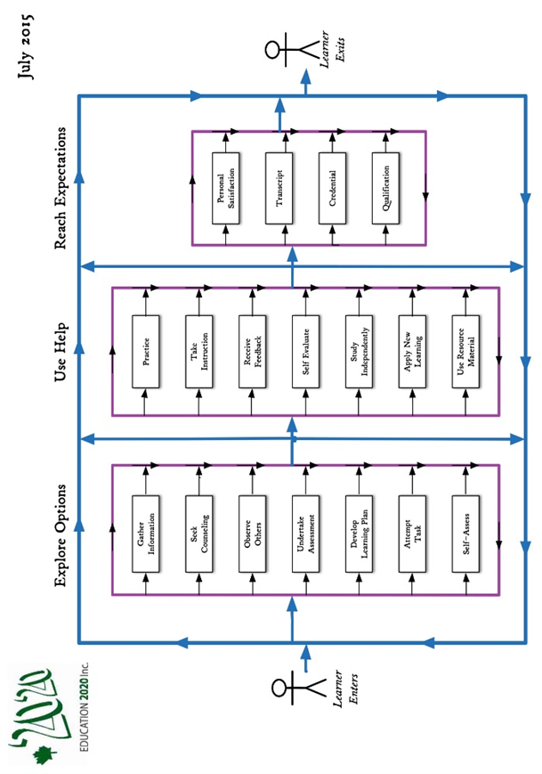

THE LEARNER

A learner is a person who, for whatever reason, is trying to bring about change in his/her life - trying to change an attitude, gain new knowledge or add to one’s skills. But learners are neither empty jars nor blank slates; each learner carries three pieces of luggage to every new learning situation:
- Certain physical, mental and emotional conditions with which the learn was born.
- Prior learning resulting from formal study, home circumstances, travel, state of health, personal interests, culture in which they operate and learning styles
- Aspirations and imagined future including where one will live, the work one will do and the lifestyle one will have, the nature of the family, quality of life, etc.

Our future may require a different mix of attitudes, skills and knowledge than the ones we now have; the process of developing the new mix is called learning; the discernable change that occurs in us as a result of learning is education, and people who help us learn are usually called parents, or if paid, will likely be called teachers

Most of us need help in at least some of our new learning experiences; students tell us that they sometimes need:
- Information: recent, independent, reliable, timely
- Presentation: tutoring, demonstrations, discussion and debate
- Feedback: effective, valid, transparent, relevant
- Counselling: planning, coaching,
- Opportunity: access, time, funding, transportation
- Products and technologies: textbooks, references, self-instructional material and assistive technologies

Educational BELIEFS
One gains an education through learning; education is the result of any learning experience that has a formative effect on the way a person thinks, feels or acts. Below are a number of beliefs that shape one’s views of education:
- All people can learn but some may need more time and assistance than others.
- Learning is an individual matter but may occur in a group setting.
- The most important part of one’s education is the part that occurs in the first six years of life.
- The purpose of education is to help a person gain attitudes, skills and knowledge that will serve them well for the remainder of their life’s journey.
- The responsibility for one’s education rests with one’s parents and/or one’s self.
- Our future as a community depends, in a large measure, on the nature and level of education of our citizens.
- Government’s role is (1) to encourage education among its citizens, (2) to ensure equity in its support and (3) to ensure the existence of skilled workers for the future of the community it serves.
- An education system should be designed to deliver educational services needed by its citizens to the extent possible if, as and when needed.

namic Rating Scale

Skill-based curriculum demands criterion referenced assessment; one such rating scale appears below.

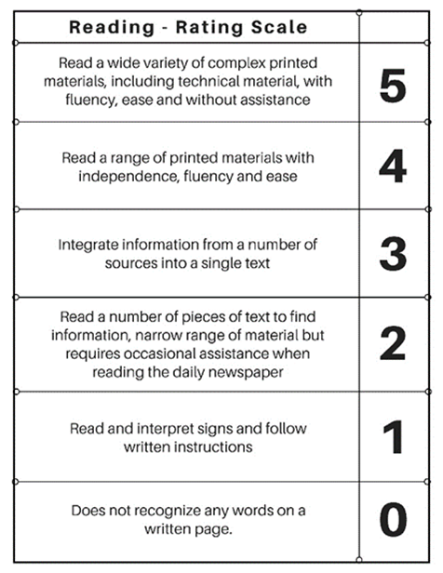

Benchmark
A level of performance which is widely recognized by practitioners and the public atlarge and serves as a rwference against which others are judged. A person could demonstrate a “3” on the scale above, by carrying on a conversation about items in the morning paper conversation .

NOTES ON QUALITY

Much has been written about improving the quality of Education;selected reference include:

UNICEF, The International Working Goup on Education, Florence, Italy, 2000
A quality education system is one where:
- learners are healthy
- Environments are safe and respectful
- Content is relevant
- Outcomes are linked to personal and community objectives
- Support is focused on learners and learning.
- Information and advice is timely and independent
- Teachers are professional, autonomous and accountable

OECD, PISA in Focus, OECD, 2011 studied PISA results in 13 countries and concluded that “in countries where schools have greater autonomy” over what is taught and how students are assessed, students tend to perform better”.

MEI, (2015) an Educational Think Tank in Quebec concluded that “accountability and autonomy” jointly applied, are key factors in school achievement”. He goes on to say that that “changes to accountability and autonomy would cost government nothing, would entail better academic results and allow education to better adapt to the diversity of student needs and aptitudes”

A CALL FOR ACTION

On April 9, 2015, in the midst of a Provincial election, Education 20/20 Inc. issued this Call for Action.

- A “clear and compelling” vision of education for all Islanders. We believe that having such a statement is required, especially for a service as large and complex as education

- A learner centered service model that provides support in all domains to learners if, as, when and where needed. Doing so would involve student centered outcomes, criterion referenced assessment, flexible scheduling, challenge for credit arrangements, and greater autonomy and accountability for teachers.

- Leadership in the creation of a learning culture and providing a quality education for every Islander. Government should focus on matters of planning, setting priorities, funding, monitoring, and quality control, ensuring the availability of professional resources, home sup-port for preschool children, information and continuing education.

- Autonomy for schools in their day to day decision-making

- An independent qualification body for the purpose certifying individual levels of achievement for persons wanting or needing such documentation.

- A service delivery model where professionals are directly accountable to clients for the nature, extent and quality of service provided

- Put in place an externally controlled strategy to encourage and support innovation.

ROAD OF LIFE

The road is a metaphor for the experiences one encounters between birth and death. The literature suggests that each person fills a number of roles, that of an individual, family member, citizen, learner, producer and consumer – a challenging road to say the least.

While each reader could make their own list of essential skills, I suggest that most would likely include the following:

- Literacy
- Numeracy
- Community awareness
- Self-management
- Interpersonal reltionships
- Zinformation technology

EDUCATION SERVICES

Education is a service industry but services are seldom separately identified. The list that follows coes from two min sources (1) a panel of young people who were invited to talk about he help they needed during the learning process and (2) a review of the education literature. While there is no acknowledged standard list, educational services would normally include:

- Governance: leadership, funding, quality control, human resources and information and Information,
- Instruction: counselling, presentations, practice, diagnosis and access
- Quality assurance: evaluation, certification and qualifications
- Access: transportation, facilities and internet
- Products and Technology: textbooks, wi-fi, hardware, MOOCS, facilities and software
- Information and Counselling: information and counselling, assessment and advocacy

When designing an education, for each service to be offered, planners would be expected to:
- Describe its the nature and importance
- Estent to which it is needed and by which citizens
- Degree of financial support
- Preferred provider

CURRICULUM

Most curriculum development in Canada is outcome based; our examination, however, identified significant differences in the the way that curriculum is defined, described and organized. Some use say education outcomes, Atlantic Canada uses cuticulum outcomes and some suse skills. For our purposes, weve decided to use competencies because that term seems to be on the ascendancy:

Curriculum development steps include:
- Anlying the field
- Share curriculum map with allusers
- Select skills to be offered
- Develop support materials for each skill
- Adopt community based assessment criteria
- Develop a dynamic rating scale.
- Teachers select textbooks and other lerner support materials

See sample rating scale elsewhere in this booklet

ESSENCE OF EDUCATION
The provision of a quality of Island education is one of the most important ssues of the day in that it will determine, to a large degree the quality of our individual lives as well as the community in which we live. Definitions could include:
• Education - any experience that has a formative effect the way a person thinks, feels and acts
• Quality education: “one that provides all learners with capabilities they require to be come economically productive, develop sustainable livelihoods, contribute to peaceful and democratic societies and enhance individual well-being”-New Zealand,
- A sector of the economy “primarily engaged in providing educational servives incdfing informstion, instruction, counselling.
- A Government Department that part of government voncerned with providing instructions to weople in schools

